**Technical Test for BCredi**

**Description**

This application consists on a tool to manage delayed installments of contracts. Using this tool, the user can schedule new Bank slips for renegotiate the payment conditions by selecting the delayed installments from a contract.

Technical specification

The application has been built in Asp.Net Core MVC, with Entity Framework Core and In Memory Database.

**Configuration**

Before the first use, it will be necessary to refer to the “appsetting.json” file and replace the information in section “EmailSettings”, this information will be necessary to authenticate through the SMTP of the chosen e-mail provider, to allow the application to send notification e-mails.

**Running the application**

If using the CLI-Tool, open the command prompt, navigate to the project directory and run the following commands:

dotnet build  
dotnet run

It will start the application on a network port, e.g., <https://localhost:5001>, then open the address in your browser.

To check the api endpoints, please refer to the “/swagger” address, e.g., <https://localhost:5001/swagger> .

If using Visual Studio, you just need to run the “BCrediTest” project.

**Using the application**

1 - When using the application the first screen that you will see is the Contract List, it has no entries since no data was uploaded yet.

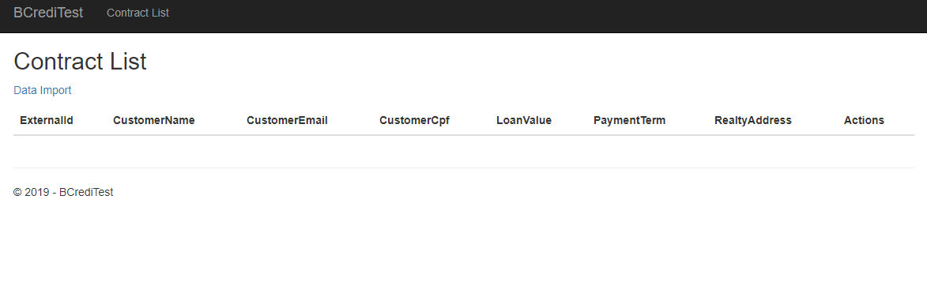

2 – Navigate to the “Data Import” screen, select the file type on the dropdown list and load the file. If the file and the type selected doesn’t match, a popup should appear informing that the upload was not completed.

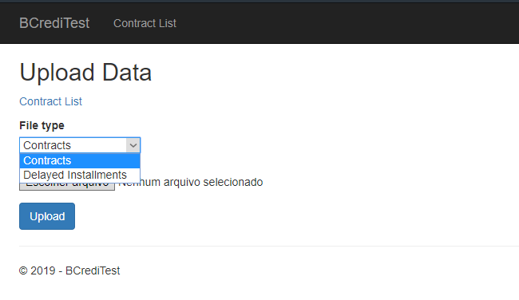

3 – After uploading both files, you can go back to the previous screen and see the list of contracts loaded

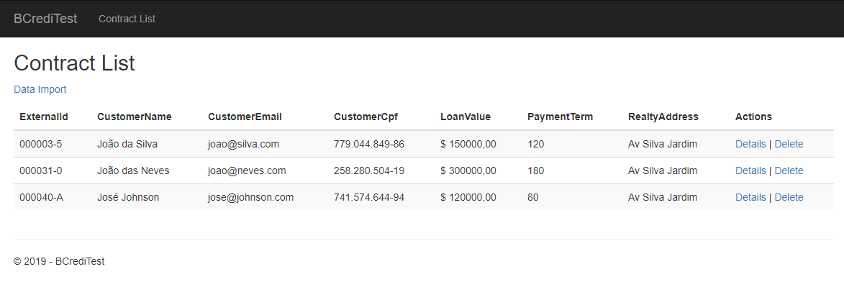

In this screen, you have 2 options: delete the file from the list or see its details.

4 – Opening the details of a selected contract, you will be able to see each delayed installment and bank slip scheduled for it.

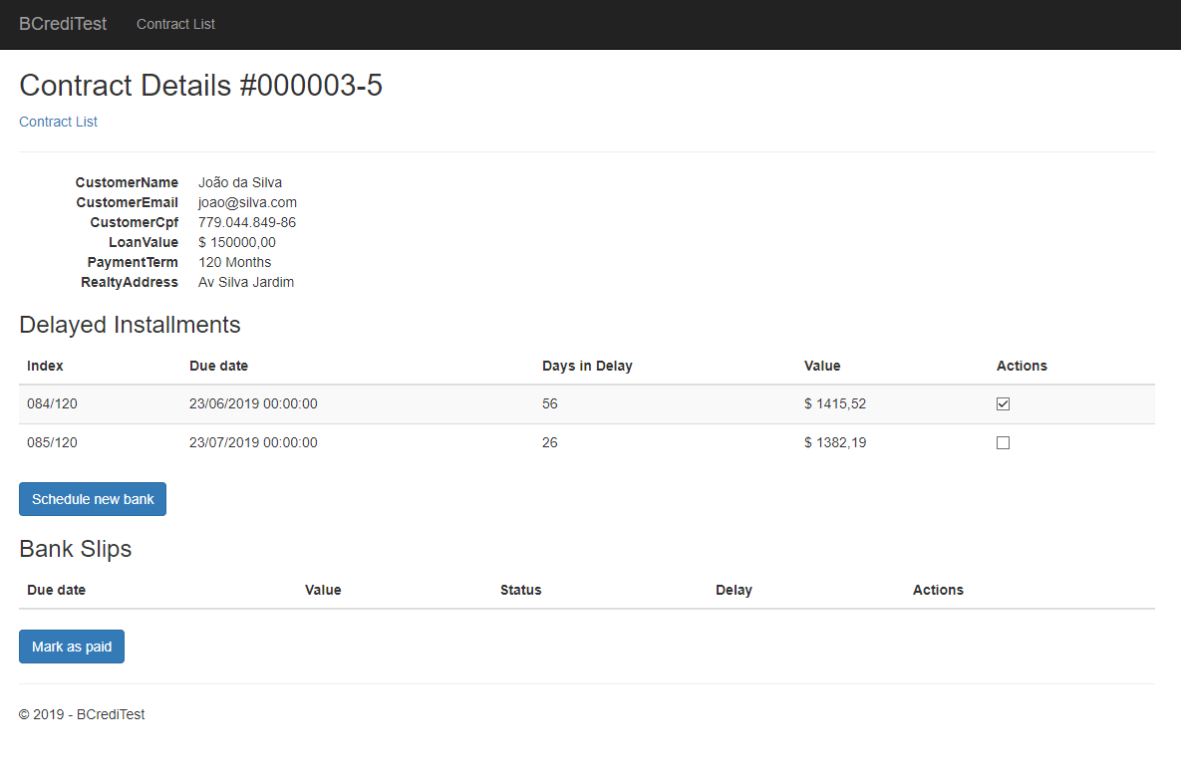

5 – After selecting the desired installments, you will be able to schedule a new bank sli, by selecting a Due Date for it. (The fee and interest values are pre-loaded, but you can change it)

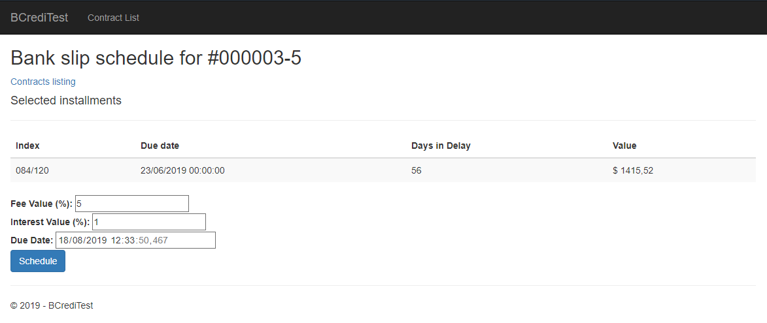

Select a date greater than the actual date and click in schedule, an email will be sent to the customer with the bank slip data. You will be redirected back to the contract details and then you will be able to see the new bank slip on the list.

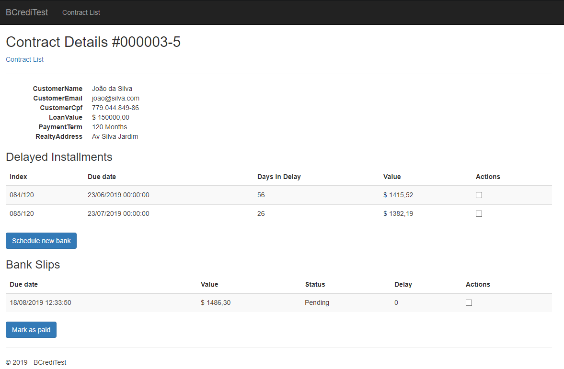

6 – If you select a bank slip and click on “Mark as paid”, even the bank slip and the related installments will be removed from the list.

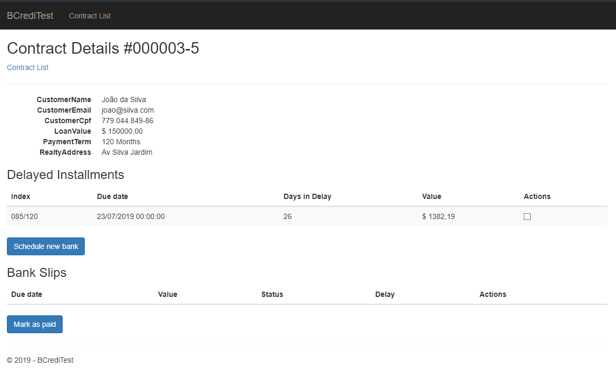

There is another way to mark a bank slip as paid, it can be done by using the API Controller with an array of ids of each bank slip you want to inform as paid.